FPL2FMS

###### FPL2FMS is an app to convert Garmin FPL files, which is generated by SkyVector, to X-Plane 11 FMS files, which is used by X-Plane 11 GNS430, GNS530, G1000, and default FMS.

## Installation & Uninstallation

Download and run the installer for your system (WindowsSetup for Windows, and LinuxSetup for Linux). The installer will install the app step-by-step. On Windows, the installer will make a start menu entry and a desktop shortcut. On Linux, it will make a menu entry.

The app can be uninstalled from Control Panel on Windows like any other app, and by running the ‘maintenancetool’ file in the app installation folder on Linux.

## Usage

After planning the route on SkyVector, export it as an FPL file by clicking the “Send Plan To...” button. In the popup, click on the Δ.fpl symbol, and download the FPL file.

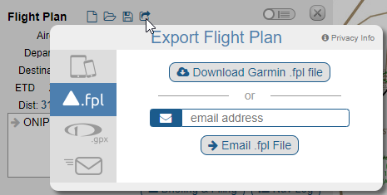

Open the app and select the FPL file, and enter the flight route by copying and pasting it from SkyVector. The reason for entering the flight route is that the FPL file contains the waypoints data only, but not the airways. So in the G1000 and default FMS, the waypoints will appear individually, not connected to an airway.

Don’t write DCT between direct waypoints, instead, separate them by a space.

After entering the route, click on the convert button.

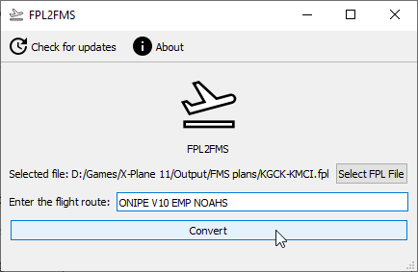

A dialog will appear and ask to select where to save the file and to enter its name. To load it in X-Plane, the file must be saved in “X-Plane\Output\FMS plans” folder. Enter any name you want and click the save button. The app will convert the file.

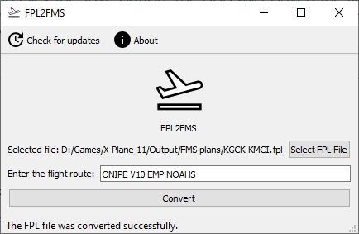

Note that if X-Plane 11 AIRAC cycle isn’t the most recent one, a warning might appear when loading the plan in X-Plane. That’s because the app assumes that the route AIRAC cycle is the most recent one. The plan can still be loaded.

## Reporting bugs

If you encountered a problem, make sure that the route you entered is the same route used to export the FPL file. If the problem persisted, [open an issue on the GitHub repository](https://github.com/abdullah-radwan/FPL2FMS/issues/new) and attach the FPL file, flight route, FMS file, and “log.txt” file which is in “%appdata%/FPL2FMS” on Windows, and “~/.local/share/FPL2FMS” on Linux.

## About

FPL2FMS is a free and open-source app under the GPL v3 license. The source code can be found in [the GitHub repository](https://github.com/abdullah-radwan/FPL2FMS).

Email: [abbodmar@gmail.com](mailto:abbodmar@gmail.com)

Copyright © Abdullah Radwan